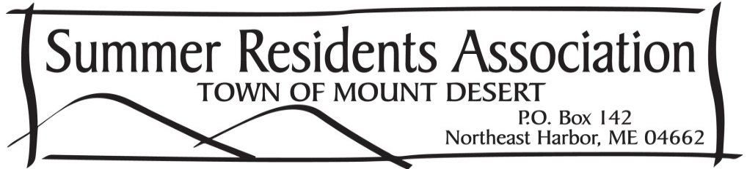
Jack Katz
Will Hudson
Cammie Disston
Marnie Phillips
Whitney Drayton
Perot Bissell
Elizabeth Johnson
Frances Fremont Smith

Jim Green
President
Ned Nalle
Vice President, Nominating
Gary Madeira
Treasurer & Secretary

The mission of the Summer Residents Association (SRA) of the Town of Mount Desert is to provide an effective means of communication between the summer residents and the town leadership on issues that concern the current and future well-being of the Town. The SRA Board of Directors seek to represent and to keep the summer community informed of, and involved in, the Town planning process on current and future issue. The SRA has a board representing most villages in the Town of Mount Desert.

The Summer Residents Association seeks to be the timely and constructive voice of the summer residents with Town government, working closely with Town leaders to preserve and protect the unique character, culture, environment and quality of life in the Town of Mount Desert.

In 2022 we saw the expansion of the SRA Board with the election of Elizabeth Johnson, Jack Katz and Frances Fremont Smith, last August, bringing the board to 11 members. These new Board Members bring fresh eyes and perspective from Otter Creek, Somesville and Pretty Marsh. To build further on this momentum, we are aiming for a more gender balanced board (35% women to 65% men at the moment) and we’d like to increase our overall membership and board membership by bringing in representation of the younger generations. We saw a slight rise our membership to 253 families and our goal for 2023 is to bring in new members. To that end, our membership rate of $25 per year will stay the same. If you own or rent property in the Town of Mount Desert, but do not have voting privileges, consider joining: info@123neh.com for more information.

In an effort to increase attendance; we held only one Members Meeting last year as we were testing a new format. As it was a successful meeting with attendance up dramatically, in 2023 the SRA will continue with the new format but return to one meeting in July and one in August. In honor of the passing of Buddy Brown and Dana Haynes, Tom Brown and Wendy Littlefield were guest speakers. Their tributes were touching and heart-felt and for all the SRA members in attendance, it was a meaningful way to remember Buddy and Dana’s enormous contributions to the town and their commitment to keeping a solid tie between the local and summer community. Kevin Schneider, Superintendent of the ANP also spoke and gave the members an update of the 2022 season. Attendance in the park was down only slightly from 2021. He also spoke of the challenges in meeting the housing needs of the park staff to keep up with the increasing popularity of ANP.

We put more effective and environmentally responsible communication into play with our social media sites on Facebook (Summer Residents Association, Town of Mount Desert) and Instagram (Summer Residents Assoc MDI). Our social media pages are the best way to keep up to date in a timely way. We continue to send a digital newsletter and digital updates via email as well and we reduced our paper trail considerably by sending paper newsletters to only a small portion of the membership that specifically requested them.

There are multiple hot topics in town this year: Short term rental licensing ordinance, the proposal to reorganize the schools into one district, the addition of workforce housing within the town and on the island, the institution of a code of ethics to address conflicts of interest on town boards are all being discussed during the off season. The SRA has a goal for 2023: to better determine consensus to constructively use the voice of its members to communicate with the local government leaders to preserve, protect and support the unique quality of life for all residents of the Town of Mount Desert.

The 2023 SRA meetings are open to the whole community and we encourage you to attend and provide your feedback.
Respectfully submitted,
The SRA Board of Directors 2022-2023

