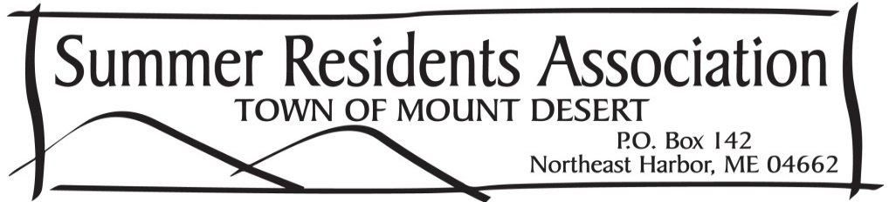

Chris Reece
Will Hudson
Cammie Disston
Marnie Phillips
Whitney Drayton
Perot Bissell

Jim Green
President
Ned Nalle
Vice President, Nominating
Gary Madeira
Treasurer & Secretary

The mission of the Summer Residents Association (SRA) of the Town of Mount Desert is to provide an effective means of communication between the summer residents and the town leadership on issues that concern the current and future well-being of the Town. The SRA Board of Directors seek to represent and to keep the summer community informed of, and involved in, the Town planning process on current and future issue. The SRA has a board representing most villages in the Town of Mount Desert.

The Summer Residents Association seeks to be the timely and constructive voice of the summer residents with Town government, working closely with Town leaders to preserve and protect the unique character, culture, environment and quality of life in the Town of Mount Desert.

Speakers at the summer meetings and newsletters helped keep out members aware and informed of such topics as the effects and damage of the June storm in Acadia, the Main Street Project, the MD 365 project at Manchester and Neighborhood Road, the reopening of the Northeast Harbor Medical Center, the plans for the absorption of the Volunteer Ambulance Service by the town and the Broadband Initiative.

In August, Maggie Hays, Bill Roberts, John Boynton and Matthew Baird finished their second terms. We extend one more thank you for their energy and help with the Covid Relief Fund and for their years on the Board of the SRA. At the members meeting in August the 2021-2022 board was elected: Jim Green (President), Ned Nalle (Vice President and Nominating Chair), Gary Madeira (Secretary and Treasurer) and Cammie Disston, Marnie Phillips, Perot Bissell, Whitney Drayton, Will Hudson, Chris Reece (Board Members).

2021 saw our membership increase from 172 households to 242 households. Part of the increase was due to the switch from paper billing to digital billing; part was due to members’ efforts in making new families aware of the SRA and our mission. In analyzing our increased membership, we realized that 70% of our members are comfortable with and prefer a fully digital form of communication and dues payment and 30% prefer paper communication and dues payment.

More effective and environmentally responsible communication is at the forefront of the SRA’s goals for 2022. We are exploring traditional channels along with social media to get the information out to our membership – year round. We will also endeavor to better communicate the voice of the summer resident back to town leadership.

The 2022 SRA meetings are open to the whole community and we encourage you to attend and provide your feedback. Please find current dates and the SRA newsletters online at www.SRATMD.org
Respectfully submitted,
The SRA Board of Directors 2021-2022

